Commercial Property Management Guide

Contents
Introduction 4
New Account Checklist 4
Create New Contact – Salesforce 4
Guarantors 4
Set up Commercial Unit - Qube 5
Interest Tab – Unit level 5
Accounts Outside the 1954 Act 5
VAT on Commercial Properties 6
VAT on Commercial Deposits 6
For Aldershot Commercial Properties 6
Posting Service Charges for MOD accounts 6
Debit Periodic Charges 7
Send prelist of charges 7
Run Debit periodic Charges 9
Demand Suites - MOD vs MOD2 9
Raising Commercial Invoices 9
Setting up new lease 11
Same customer – new lease 11
Portfolio Variation Form (PVF) 11
Lease terms 13
Rent review/Lease end diaries 13
Add tenant information 14
Add User Info 14
Commercial Deposits 15
Raising a Deposit Charge – including/excluding VAT 15
Setting up New Deposit Accounts - New General Ledger Account 16
Setting up New Deposit Accounts - Client Money Scheme Account 16
New Deposit Bank Account 17
Transferring a deposit deed 18
Viewing deposit value in General Ledger Account 18
Transfer a deposit from old account to new including interest 19
Same customer – new lease 19
New tenant account 19
Posting deposit Interest 19
Same lease – New Customer 19
Draw down deposit against arrears 20
Full draw down – close deposit account 20
Partial draw down 20
End of lease 21
Holding Over 21
New lease for an existing tenant – renewal 21
Tenant inside the Landlord and Tenant Act 1954 22
Late Renewals 22
Tenant outside the Landlord and Tenant Act 1954 22
Assignment of Commercial Lease 22
Tenancy At Will 23
Checklist for setting up Commercial accounts 23
New accounts 23
Grainger costs deducted from Completion statement funds 24
Posting Service Charges from recharges (Sheila Notes) 24
Service Charge Information per unit 26
Statements 26
On Qube 26
Location Collective – Invoicing as and when – Raising Invoices 28
Raise as an additional Charge in Qube 28
Legal Action for Commercial Tenancies 29
Forfeiture of Lease 29
Commercial Rent Arrears Recovery (CRAR) – Bailiff action 29
Winding Up Petition 29
Draw Down on deposit 29
Payment Plans 29
Interest – Posting Interest Charges 30
Interest on Rent review – below base rate 31
Reprinting Aldershot invoices for VAT 31
General Ledger – Report of Commercial Deposit Accounts 32
Payment through Salesforce 33
Anglo – Quarterly turnover reports – Additional Charges 34
Appendixes 35
A Guide to the landlord and Tenant Act 1954 35
Updating bank interest rates 38
Sheengate Mansions Service Charges 39
Example Commercial letters 41
GTCOMM1 – Gentle reminder – Outstanding entries shown 41
GTCOMM2 – Gentle reminder – No Outstanding entries shown 41
GTCOMM3 – Reminder – Payment within 7 days 41
GTCOMM4 – Final Warning Letter 42
GTCOMM8 – reminder for Non Rent/SC – e.g. Insurance 42

Introduction
It should be noted that this is a general guide, and each Commercial lease may have specific nuances that need to be taken into account.

New Account Checklist
PVF received
Lease and Deposit Deed received NB: Aldershot do not hold deposits
Set Up Contact and Guarantors in Salesforce
Update Unit Information
Add diaries – lease end/rent review /break clauses
Add interest rates if applicable
Update tenant information/create new tenant account
Update Tenants Data fields for Salesforce
Request New GL account and New Deposit Account - (NB: Aldershot do not hold deposits)

Create New Contact – Salesforce
Commercial Units Financials are held in Salesforce under Contacts rather than Accounts
Select “+New Contact ”from drop down options


Guarantors
On the Parent tenant, add YES to Guarantors field on the User Info Tab
Guarantors need to be set up as Contacts in Salesforce, then as Child Tenants
In Child tenants Data Tab, add occupier type as ‘Guarantor’

Set up Commercial Unit - Qube
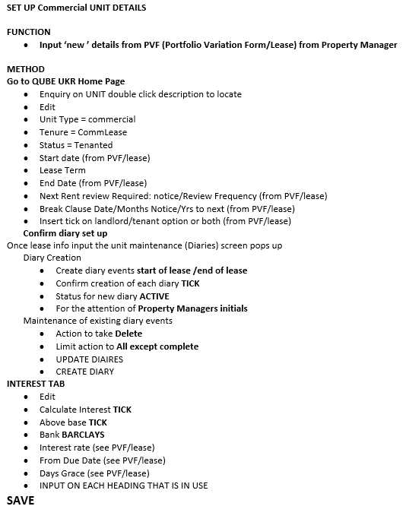

Occasionally have Commercial leases etc that aren’t Commercial Units.
If Unit Type is not ‘Commercial’ add the Statement/Demand Code COMMER to pick up for charges/invoices.

Interest Tab – Unit level

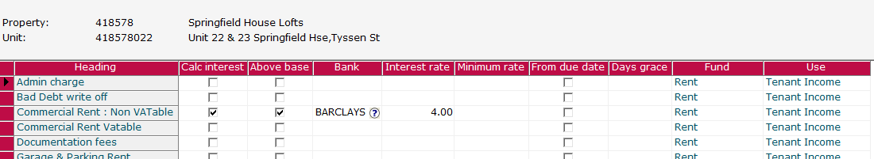
Example of options – 4% above bank rate

Accounts Outside the 1954 Act
Charges must be ended at the end of the lease and cannot hold over

VAT on Commercial Properties
VAT may be charged depending on whether the property has been elected for VAT – there are some variances where the block may be opted in but a particular unit does not incur VAT or vice versa
This will need to be checked on a case-by-case basis.
Check on the Property level whether property is VAT elected

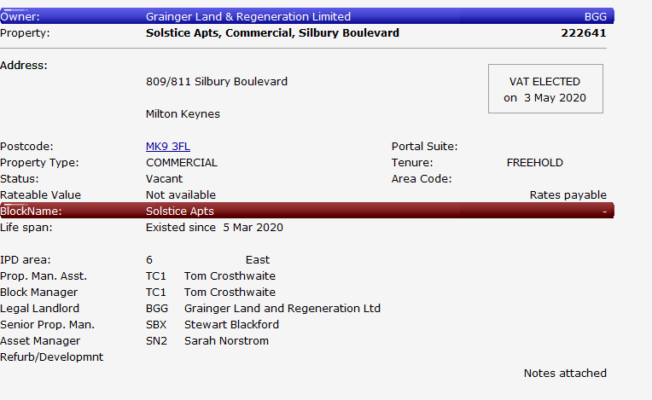

VAT on Commercial Deposits
Raise the total amount as Gross with VAT as out of scope
Commercial deposits charges are raised on the tenant account under nominal XXXLAXXXXX

For Aldershot Commercial Properties
MOD demand suite will pick up the VAT number from the owner field in Qube
MOD2 demand suite will use default VAT number 888 8050 68

Posting Service Charges for MOD accounts
Aldershot accounts may have an annual service charges payable at a fixed rate.

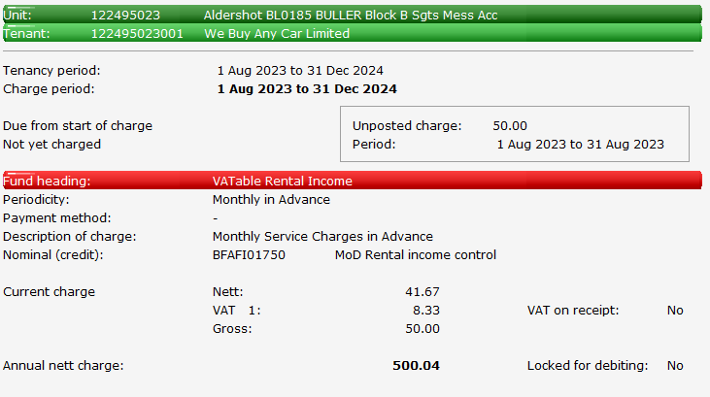
These charges should be added as Vatable Rental Income

Amend Description on Charge

Debit Periodic Charges
Applies charges to the tenant accounts

Send prelist of charges
Property Managers should check this pre-list to confirm charges are correct.
Also helps them identify any leases that are ending.

Send pre-list of charges around 20th of each month for charges to be run for following month
Aldershot Only
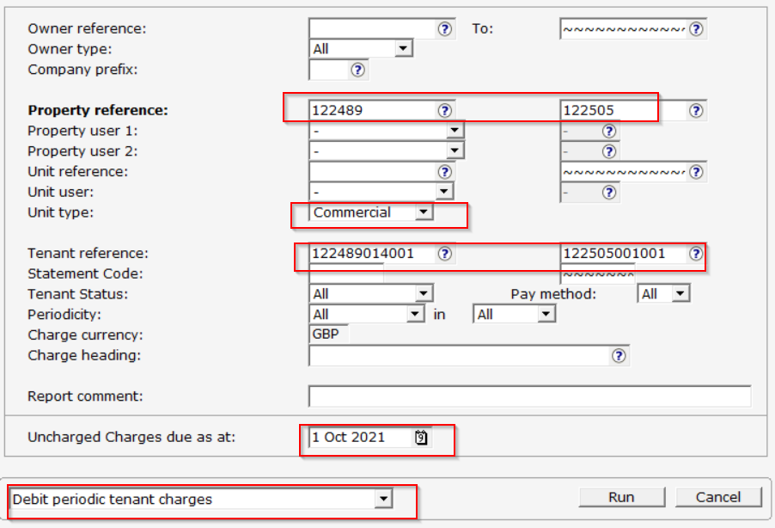
Send pre-list for Aldershot to Meg Lancaster and Alan Chitson

Note property and tenant References

Amend date as required

Repeat for property 127771 – Compounds – Berewood – COMMERCIAL Demand Suite
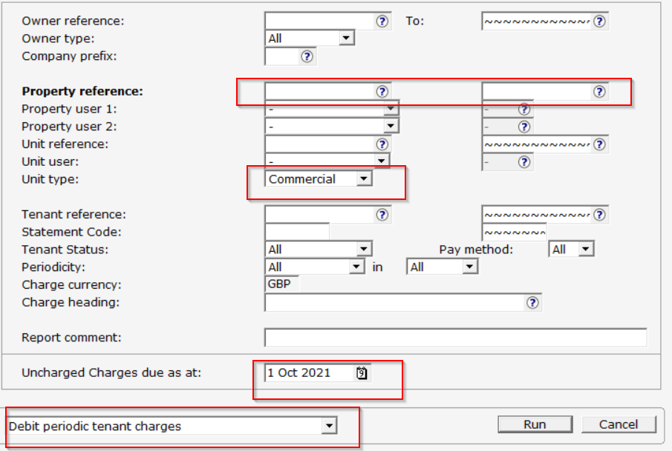
All charges

Amend date as required

Repeat for accounts with Statement Code COMMER
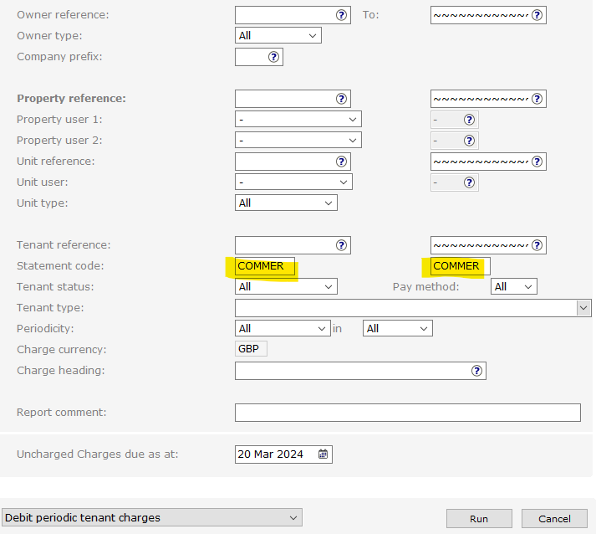
For each, Select Run – Do not Post charges to tenants
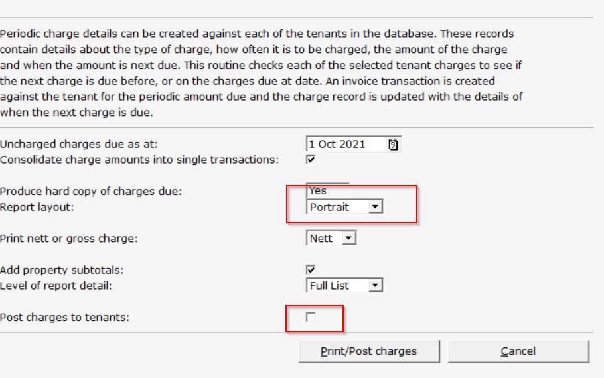

Print as Portrait to include all information

Leave box unticked

Save copy of Pre-List for future reference, if required.

Run Debit periodic Charges
Note: Always run Aldershot first - Once the pre-list has been agreed or enough time has passed to respond, repeat the process but tick the box marked process charges to tenants
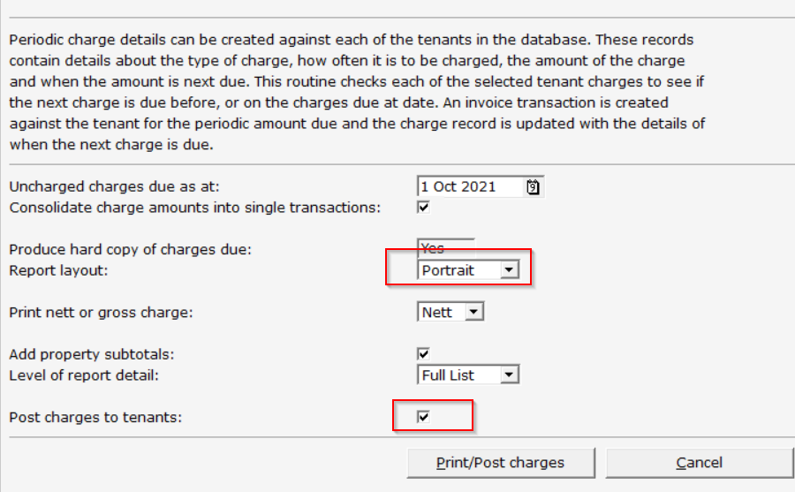

Repeat for all Commercial accounts
Invoices can now be raised for the Commercial Charges

Demand Suites - MOD vs MOD2
MOD demand suite will pick up the VAT number from the owner field in Qube
MOD2 demand suite will use default VAT number 888 8050 68

Raising Commercial Invoices
Run Aldershot Invoices first using the parameters above
Complete the report option from the main menu
This will be repeated for commercial units and other units under the commercial header
Commercial Units
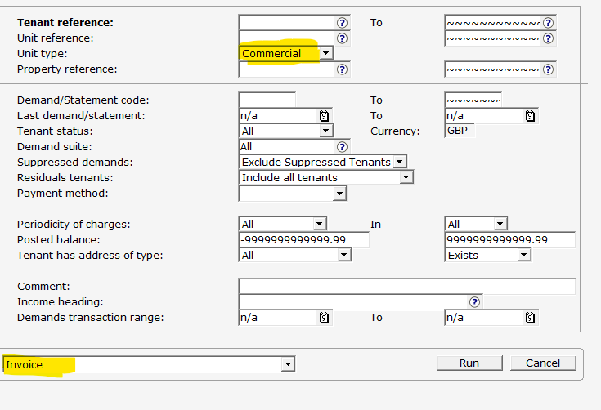
Select RUN

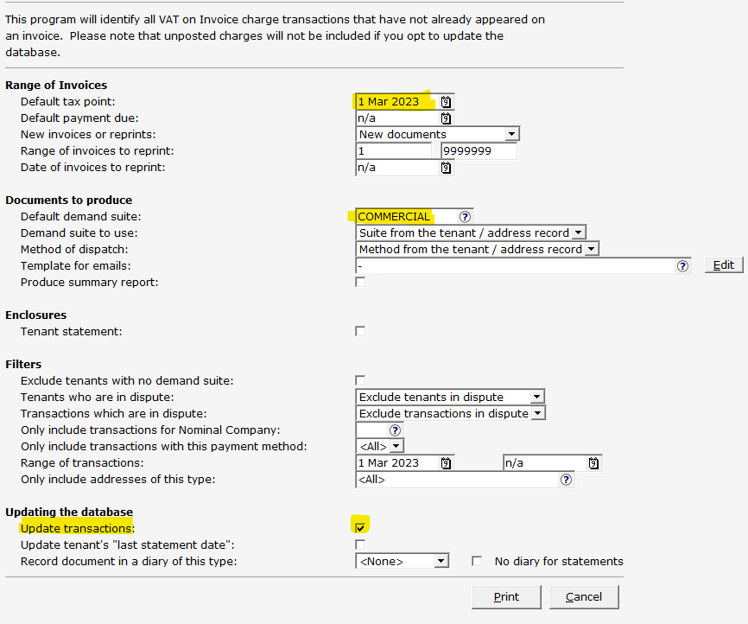
Invoice date can be amended to 1st of the month

Select Commercial demand suite

Update transaction box can be unticked to preview but MUST be ticked to produce an actual invoice

Other units may have a unit type of Dummy but have a demand suite of Commercial.
Repeat the run using the following options
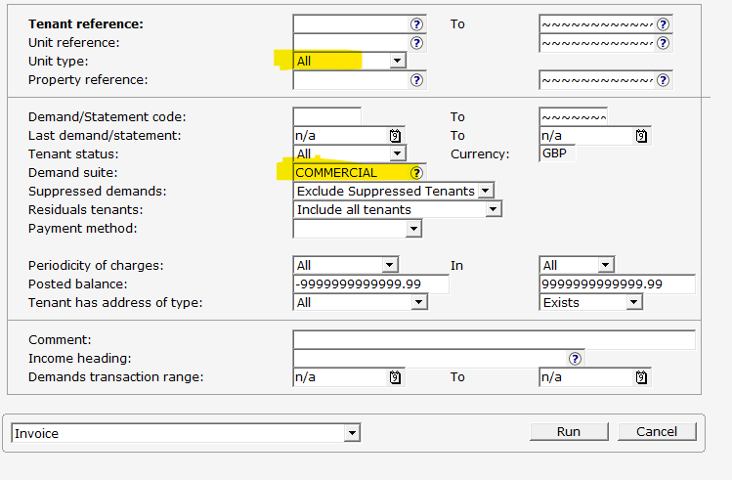
Commercial Lets
These may have a unit type of Flat PB but with a tenure of Comm-Let (for example)
Repeat for the above for any individual references – Commercial Lets or accounts that don’t pick up on invoice run
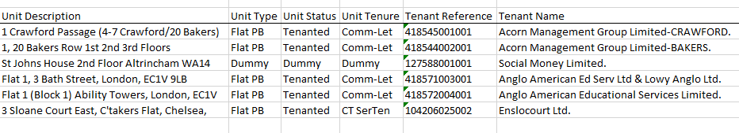

Setting up new lease

Same customer – new lease
If the tenant is outside of the Act, we will need to set up a new tenant account with the new lease details.
If they are inside the 1954 Act, we can amend the current tenant account/unit
The deposit can be transferred from the old tenant account to new using the same GL deposit code.
No need to update the interest unless included in new lease deposit.

Portfolio Variation Form (PVF)
This will provide all details with regards to lease terms, charges, rent reviews etc, for example:
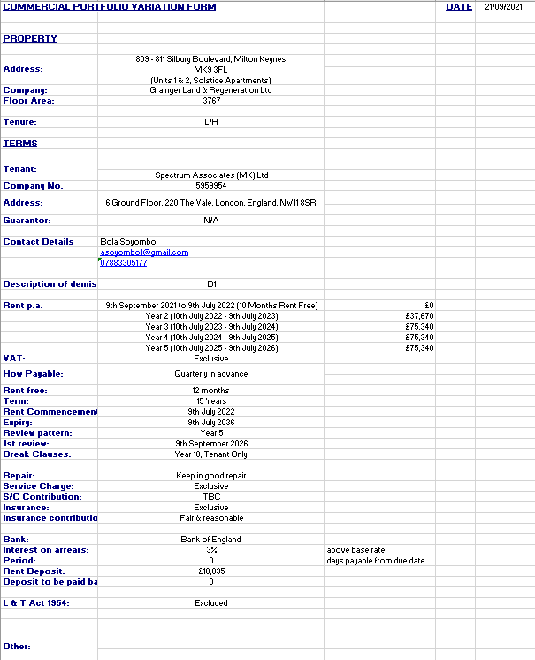

Unit descriptions may differ so have the unit ref confirmed before opening.
This form is to be updated – SBX 24/11/21

Rent free periods should be reflected here, along with any increases.
Quarters are usually legal quarters
Rent commencement is the date actual charges start
Ins Exclusive will be outside any service charge
Deposit is held in its own Client Money Scheme account
Inclusion/Exclusion of the Act must be entered in Qube

Note: If details are not correct according to the lease, the PVF should be returned and corrected before the account is set up.

Lease terms
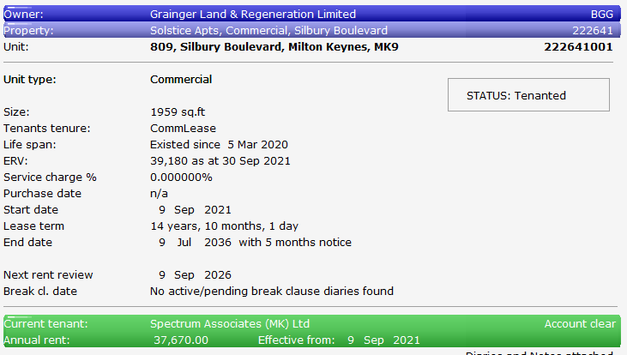
Add the lease terms to the unit

These dates apply to the current lease, even if the tenancy started previously.

Rent review/Lease end diaries
Add lease end and rent review diaries at unit level, as appropriate.
Stewart suggested 6 months’ notice on the rent review and lease end diaries.
For example:
Rent review date 09.09.26
In Qube, event Date 09.09.26
Action date 09.03.26

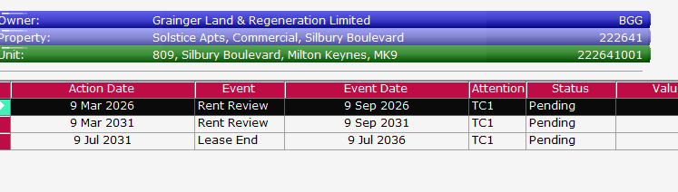

Add tenant information
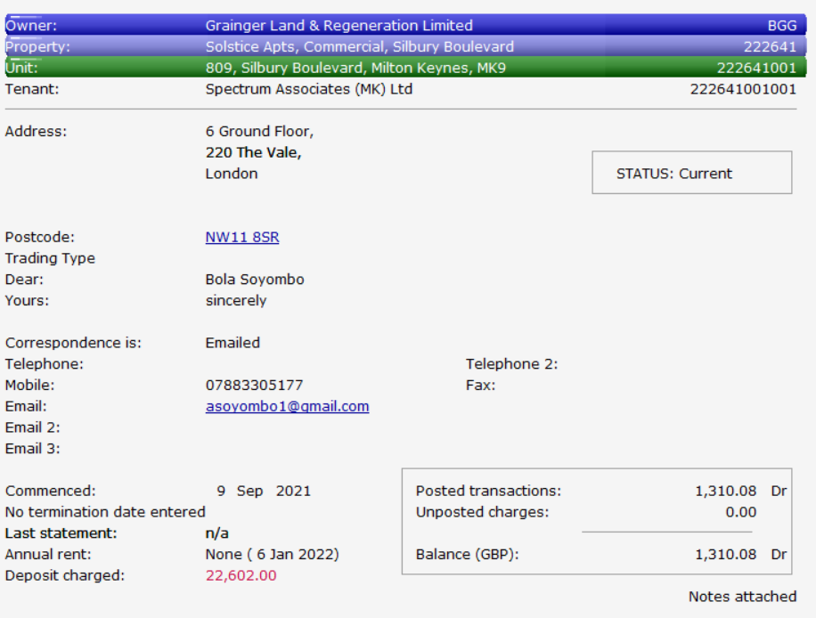
Add tenant information from the PVF form supplied. – Parent and Child accounts required.

Change status to ‘Current’

Complete start date of tenancy – leave end date blank unless contracted out, in which case complete with lease end date.

Add User Info
Update the user info to email correspondence and whether part of the Landlord and Tenant Act
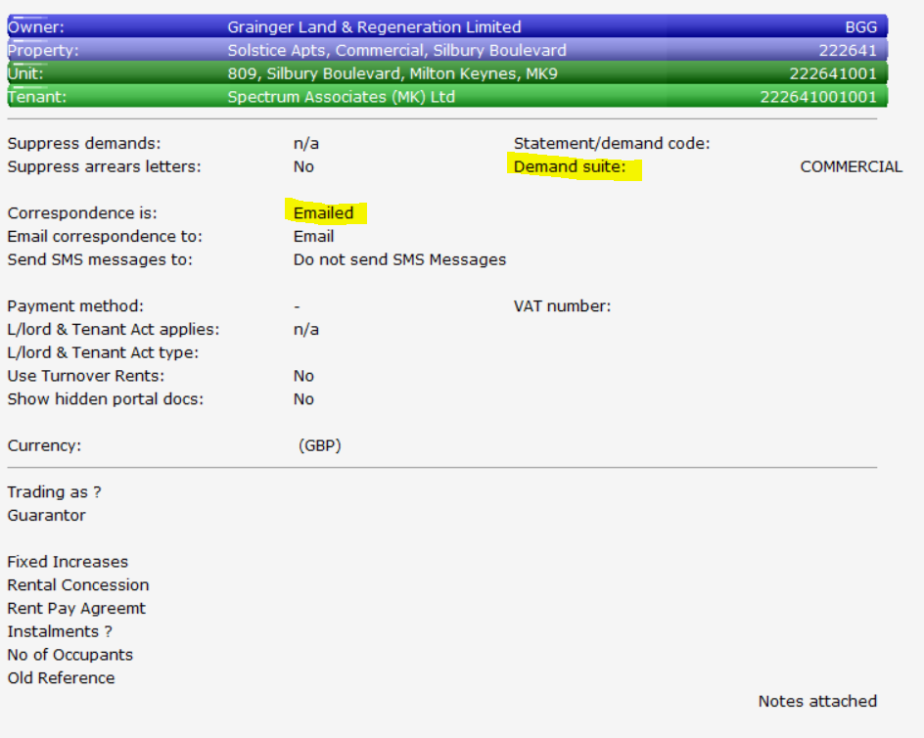
Demand Suite will depend on the Property , e.g. Commercial/MOD2 etc

Landlord & Tenant Act inclusion/exclusion is advised on the PVF

Commercial Deposits

Raising a Deposit Charge – including/excluding VAT
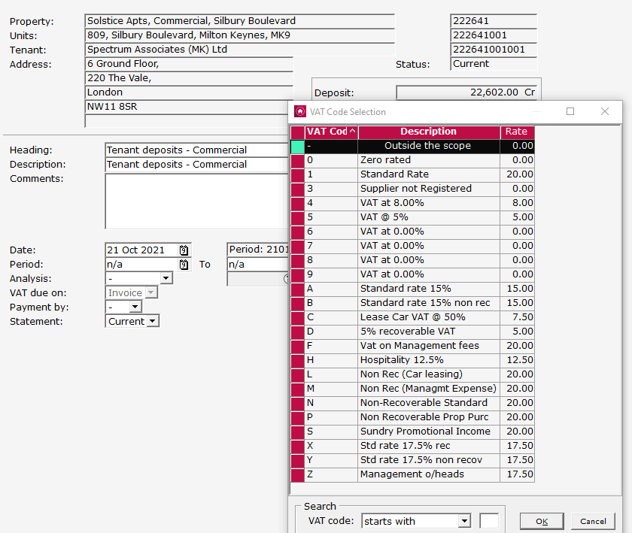
Commercial Deposits are added as an additional charge under Tenant Deposits – Commercial

VAT is usually exempt /out of scope

Lease usually refers to a Nett value – occasionally there may be reference to an amount of VAT but this should only be VATable if we do not intend to return the funds at any point.
At the time we collect the deposit, the deposit value would be the total amount paid – this will reflect on the tenant screen under Deposit Charged.
Raise the total amount as Gross with VAT as out of scope
Commercial deposits charges are raised on the tenant account under nominal XXXLAXXXXX
If Tenants Deposit – Commercial is not available under the charge headings, contact Andrea Cockbain/Lauren Ferry to add
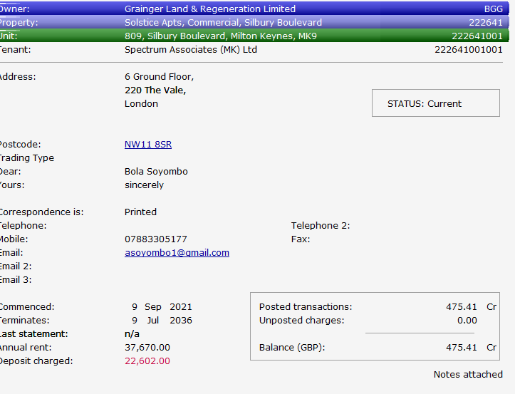

Setting up New Deposit Accounts - New General Ledger Account
Contact finance to create a new General Ledger Account
Deposit code will be in the format XXX GU XXXXX
owner ref / GU /system generates the 5 digit ref
The Nominal account name always starts with CD – Start of Company name
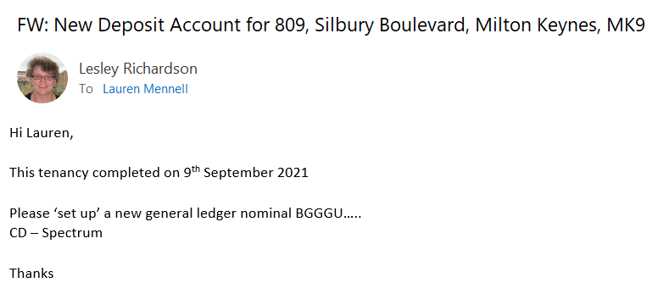

Advise when Contracts completed

Example – First 3 letters are owner code

Send this request to Katie Codd/Alex Weetman

Setting up New Deposit Accounts - Client Money Scheme Account
Email Finance to create a new Barclays Client Money Scheme Account
A copy of the Commercial Lease should be included for cross-checking
Address of Tenant is Unit address
Account Name is combination of Owner on Qube, Client Account and Company Name
Account Type – Client Monies Scheme
Short Name – As per the GL Nominal account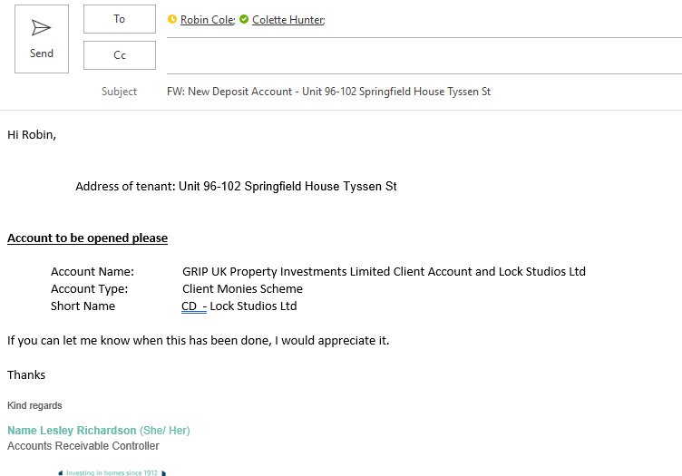
Send this request to Lauren Mennell and copy James Robertson (information only)

New Deposit Bank Account
Deposit held under Client Money Scheme Account
Once the deposit bank has been set up, Finance will advise the bank details

The funds can then be transferred into the nominated bank account
Refund the rent account, e.g. BEAGF60403
Post receipt to deposit account, e.g. BGGGU06503
Description for refund and re-post - “Payment moved from rent to deposit account”
Email finance to transfer the actual funds once posted.


Transferring a deposit deed
Deposit held under Client Money Scheme Account
A legal document is required re transferring the deposit Client Money Scheme Account
Solicitors will need to confirm the transfer of a rent deposit deed from the transferor to the transferee
Viewing deposit value in General Ledger Account
The General Ledger will show the amount of the deposit plus any accrued interest.
In Qube, you can view the General ledger account in the enquiry section.
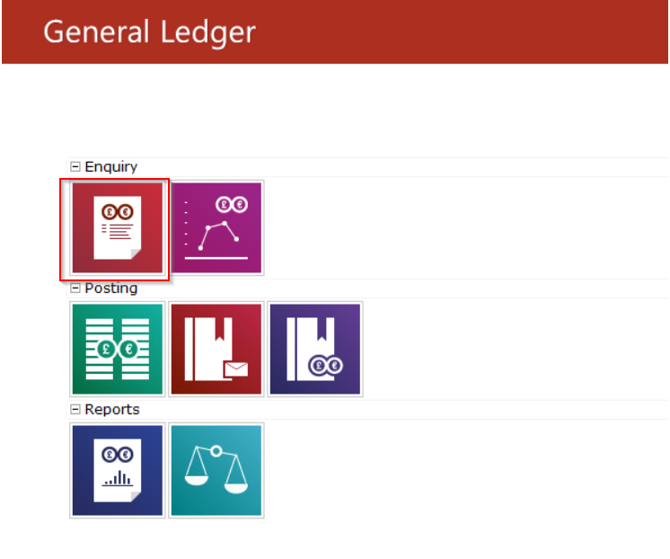

Select Account Details option

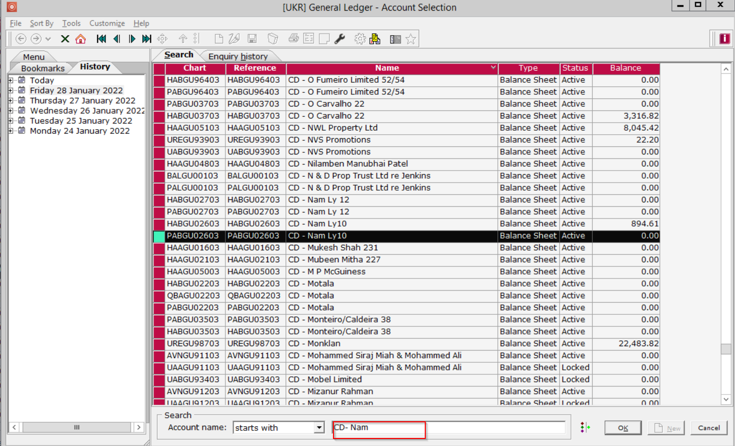
Search for Nominal account name, e.g. CD – XXXXXX

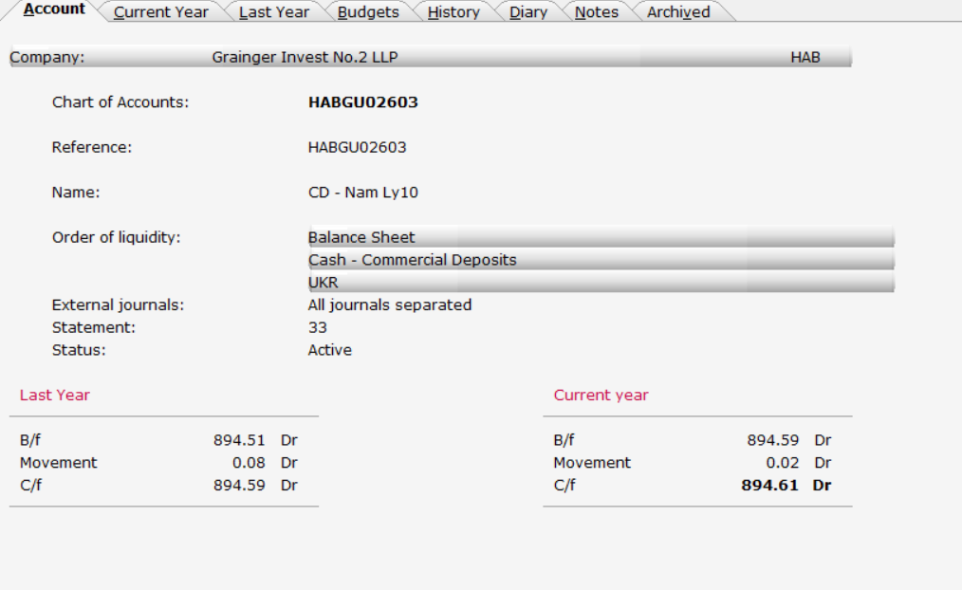

Value reflects total of original Deposit plus the interest accrued

Transfer a deposit from old account to new including interest

Same customer – new lease
If the tenant is outside of the 1954 Act, we will need to set up a new tenant account with the new lease details.
If they are inside the 1954 Act we can amend the current tenant account/unit on Qube

New tenant account
For example,
Old Deposit: 823.89
Total Interest: 70.70
New Deposit: 894.59
- Old Account: 317652005003 - post a receipt for the interest of £70.70 against nominal code XXXLH00100 (Accruals : Commercial Deposits Interest)
- Old Account: 317652005003 - post commercial deposit credit to cancel charge on the account
- Old Account: 317652005003 - post a refund of £894.59 against deposit nominal code HABGU02603 (CD - Nam Ly10)
- New Account: 317652005004 - post a receipt of £894.59 against deposit nominal code HABGU02603 (CD - Nam Ly10)
- New Account: 317652005004 - Raise Deposit Charge of £894.59

Posting deposit Interest
Post a receipt for the interest of £70.70 against nominal code XXXLH00100 (Accruals : Commercial Deposits Interest
Each of the commercial interest charge nominals end in XXXLH00100 so all we need to do is change the first three letters to match the owner code (three to use should always start with the same as the original commercial deposit bank account nominal)
Add an additional charge to the deposit nominal, if required. Otherwise, offset against arrears.

Same lease – New Customer
Lease assignment function no longer works – all postings to be done manaully
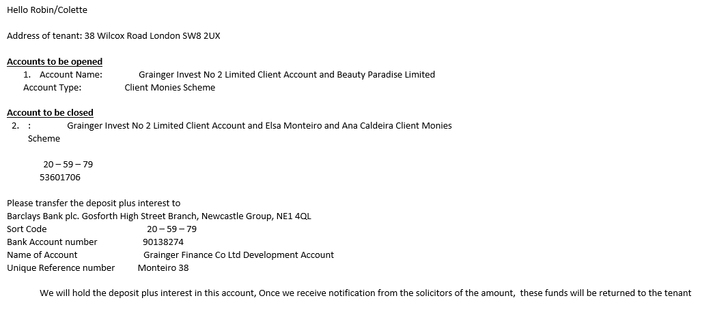

Draw down deposit against arrears
In certain circumstances we may wish to draw down all or part of a deposit and any interest against arrears on the account.

Full draw down – close deposit account
If the whole of the deposit is to be drawn down for a previous tenant, we would close the deposit account.
Example of postings
Once GL is clear can email Robin to close the Deposit account

Partial draw down
If only part of the deposit is drawn down the account would remain open
Confirm the value of the deposit account in the General Ledger, including any interest
Post any interest as a receipt on the tenant account, using nominal XXXLH00100 (Accruals : Commercial Deposits Interest), with description of “Deposit Interest used against arrears”
Raise credit against the deposit charge on the tenant account, as appropriate with description of “Commercial deposit used as rent”
Send a notification to Group finance to move the funds as required
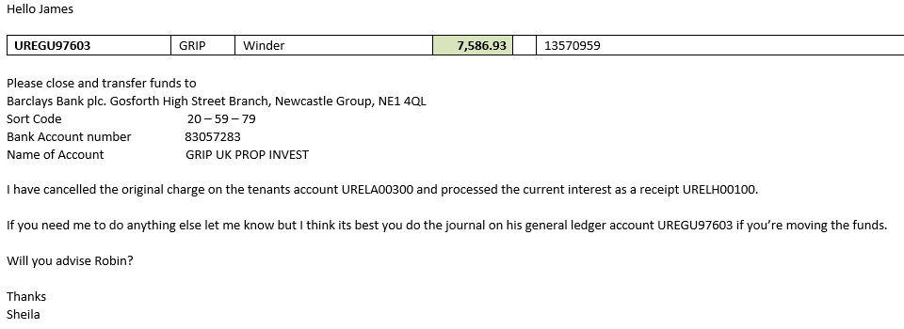
Example email to Group Finance

For GL purposes, postings on the tenant account will be a refund against XXXGU99703 (eg) and a receipt against XXXGR95003 for “deposit & accrued interest used as rent arrears” for the total of the deposit and interest on the tenant account, for the cash movement.
If the account has been reduced to zero, will need to send a notification to Robin to have the actual bank account closed.

End of lease
Charges end date applied
Need to confirm with Stewart/Tom if lease is to hold over

Holding Over
Only tenants that are inside the Landlord and Tenant Act 1954 will be eligible to ‘Hold Over’
If yes, Update Status on tenant account to ‘Holding Over’
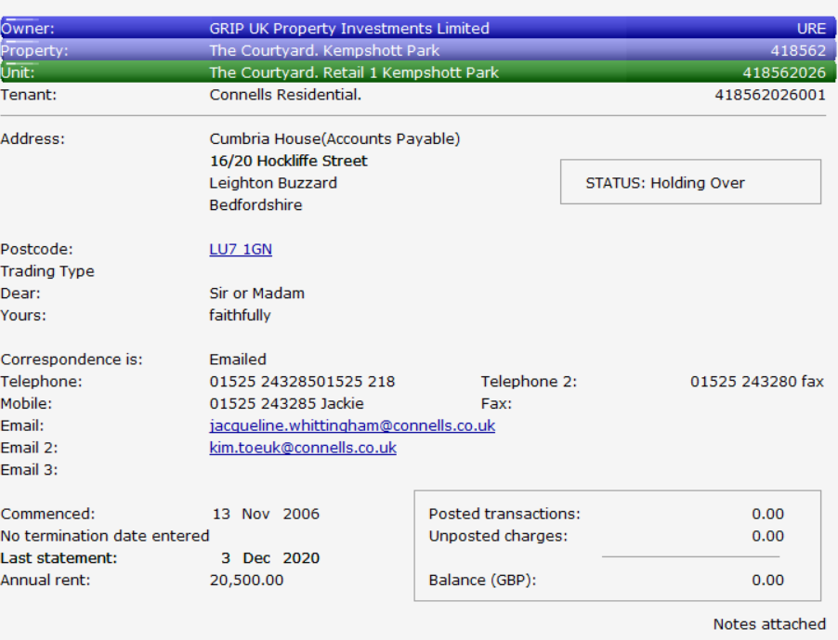
Charge end date can be removed and continue raising charges at the current rate
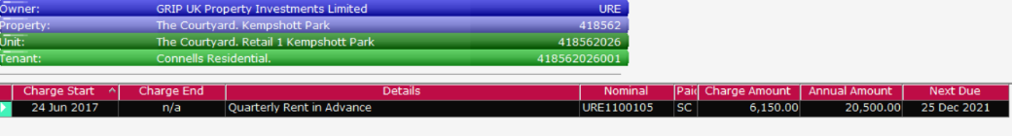
If not eligible, we cannot continue to charge rents as this will imply a lease

New lease for an existing tenant – renewal
If the tenant is included in the act, the lease can be renewed. See options below for inside/outside the act.
Note: All Aldershot accounts will be excluded from the Act

Tenant inside the Landlord and Tenant Act 1954
Unit level
Lease dates to be updated at unit level
Add rent review diaries/break clauses
Tenant level
Charges for new lease are added to the same tenant ref (use current month for finance purposes)
Any backdated charges to be added as an additional charge

Late Renewals
1. Update unit & diaries
2. Update monthly charges as follows: a. End previous charge using day before the 1st of the current month (i.e 31st May)
b. Start new charge
c. Set charge start date to beginning of the current month regardless of agreement date
d. Set next period due date & date charged up to as usual
e. Set rest of periodic charge as normal
3. Work out back rent apportionment to the date on the agreement
4. Amend direct debit if necessary following steps in 7.2
5. Only change is the start date on the periodic charge – everything else is treated the same.

Tenant outside the Landlord and Tenant Act 1954
If the tenant is excluded from the act, the lease cannot be renewed/held over.
Unit level
Lease dates to be updated at unit level
Add rent review diaries/break clauses
Tenant level
Tenant ref to be marked as previous
New tenant account to be set up for new lease period
Charges for new lease are added to the new tenant ref (use current month for finance purposes)
Any backdated charges to be added as an additional charge
Deposit to be transferred to new tenant account
Note: All Aldershot accounts will be excluded from the Act

Assignment of Commercial Lease
Complete lease assignment on Qube to transfer from Tenant A to Tenant B
Bear in mind there may be a separate service charge account, e.g.
30 Wilcox Road
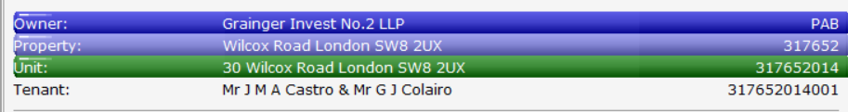
SC – 30 Wilcox Road
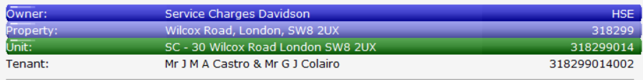
In this case, lease assignment will need to be completed on both accounts

Tenancy At Will
In some cases occupation is allowed without a formal tenancy. Can be cancelled by either party and no deposit held.
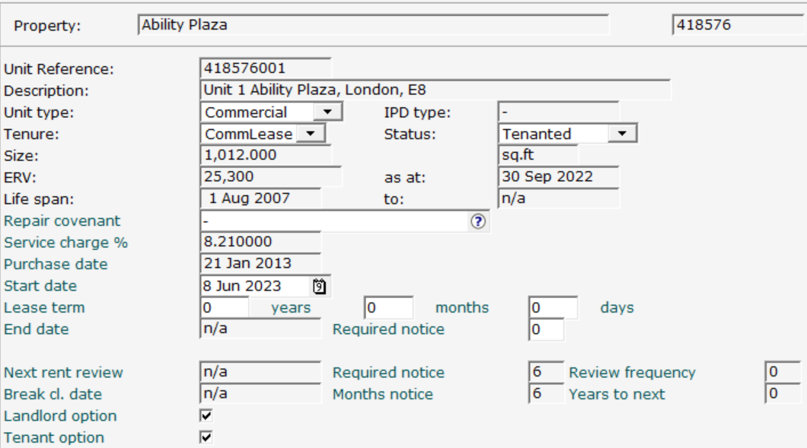
Set up as Commercial lease

Landlord and tenancy options should be selected, as per the example below - no break clauses

Checklist for setting up Commercial accounts

New accounts
PVF received
Lease received
Deposit Deed Received
Update Unit Information
Add interest rates if applicable
Update tenant information/create new tenant account
Update Tenants Data fields for Salesforce
Add rent review diaries/break clauses
Request New Deposit Account
Request New GL Account

Grainger costs deducted from Completion statement funds
Example:
Completion Statement
Rent Deposit £8175.00
Less
Planning Permission contribution £ 500.00
Total £7675.00

We will only receive the £7675.00 and must therefore post that to Qube
Postings in Qube for deposit will be:
Deposit charge of £8175.00
Deposit receipt of £7675.00
Finance will need to arrange for the transfer of the additional £500.00 to the deposit bank account and once this is done, we can post a receipt to that effect on the tenant account

Posting Service Charges from recharges (Sheila Notes)
Some accounts do not have a true service charge but have service charge invoices as per their lease
Eg Commercial S2 Indigoblu
The charges should be posted as one process in 2 steps:

- Tenant level
Raise the charge on the tenant using
Heading Miscellaneous Costs : Tenant Recharge - this will CR Recharges in the balance sheet

- Unit Level
On the unit expenditure screen raise 2 expenses:
a. An expense for the net amount posted to Tenant Recharges: Miscellaneous Costs - this will DR Recharges in the balance sheet
b. A negative expense of the net amount posted to RU-Service Charge Payable - this will CR Expenditure in the P&L

Unit level - Posting/Batch Expenditure
Period dates should be added for the charge. Would usually date at the charge from date.
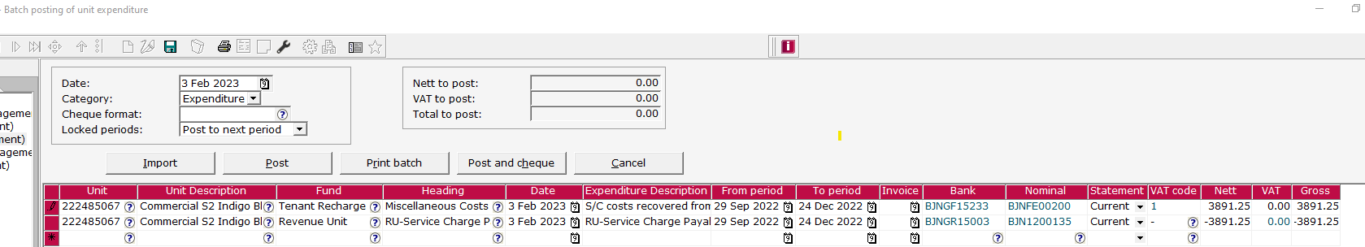
Indigoblu
Force24 222485067
Event 222485068
Units 222485066 and 222485069 do not have charges at the moment but will also need to operate in this manner if that changes.

Service Charge Information per unit

Statements
If not on docushare, will be stored on M Drive
For example: M:\service charges\GInvest\Davidson Gardens\Budgets\2022\Comm Statements 22

On Qube

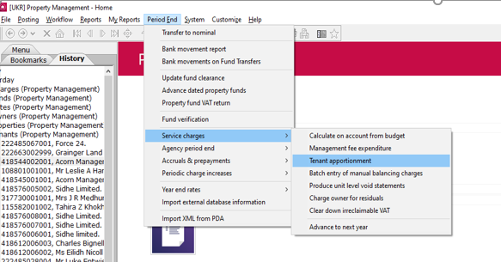
Main Menu
Service Charge
Tenant Apportionment

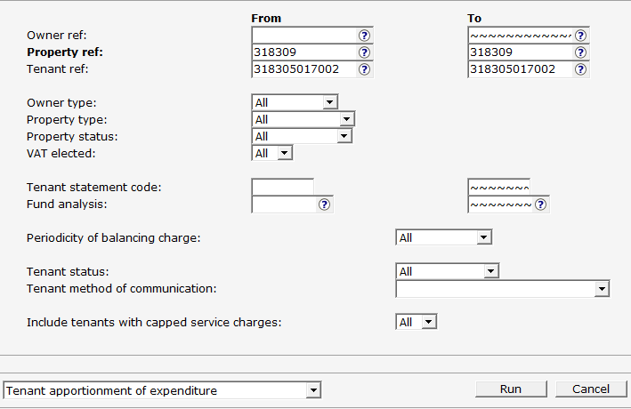

If there is a parent /child scenario, the parent account is used as that is where the service charge will be run
Change from Schedule to Heading

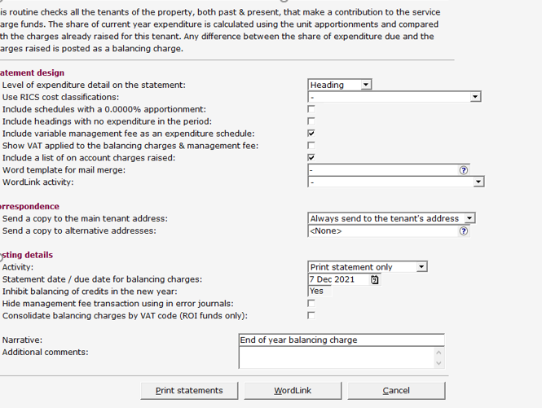

Print but NEVER post

Location Collective – Invoicing as and when – Raising Invoices
This account is used for filming and does not have a lease per se, but invoices are raised as and when a purchase order is received by Strutt and Parker
Tenant Reference - 122505001001
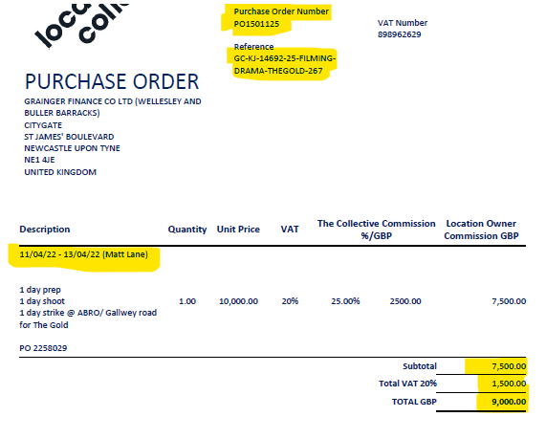
Example Purchase Order
Reference of use

Dates of usage
Person (if provided)

Amounts inc VAT figs

Raise as an additional Charge in Qube
ALWAYS RAISE THE INVOICE(S) USING THE BELOW FORMAT
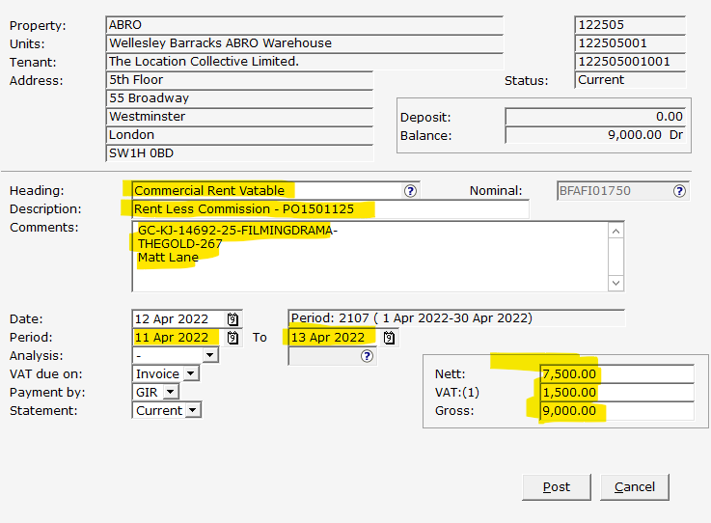
Raise as Commercial Rent vatable
Description is always Rent less Commission and the PO number.
Ref information added in Comments along with Person name.
Dates are per Purch Order
Amounts inc VAT

Email invoices to Strutt & Parker

Legal Action for Commercial Tenancies
All legal actions are managed by the property Managers.
The below is a simplified summary of actions that may be taken

Forfeiture of Lease
Lease can be forfeited by way of peaceable re-entry.
We would generally not contact the tenants if this action is to be taken.
Forfeiture enacted – Locks changed on the property
Notice instructed - posted on the property at the time of forfeiture, giving 14 days to respond. Classed as completed after the 14 days has expired.
Arrears passed to Solicitors for commencement of legal action via court proceedings – after completed.

Commercial Rent Arrears Recovery (CRAR) – Bailiff action
This action occurs with tenants still in the property, with goods more than the value of the arrears, without impacting the actual lease.

Arrears must be more than 7 days old, and may include rent, interest and/or VAT
We cannot use this process for Insurance, Service Charges or Rates

Property must be purely Commercial, not residential at all.
You should not have started any other proceedings against the tenant

Actioned by Bailiffs:
Bailiffs Instructed and issue Notice of Enforcement
Bailiffs visit and serve requiring payment within 14 days
After 14 day has expired, Bailiffs return to remove goods.

Winding Up Petition
A winding-up petition is a legal action taken by a creditor (or creditors) against a debtor company. The petition amounts to a request by the creditor for the court to wind up the company on the basis that the company cannot pay its debts. This is evidenced by its failure to satisfy the statutory demand.
Debt will need to be in excess of £10,000.00
If a debtor company is unable to pay its commercial rent due to the financial effects of the pandemic, a creditor will still not be allowed to present a winding-up petition.

Draw Down on deposit
Grainger may draw down on the deposit to make payment towards arrears.
This action can be managed in-house and does not need to be sent to the solicitors

Payment Plans
Grainger may agree to a payment plan to clear current rent and arrears which does not need to be supported by legal action

Interest – Posting Interest Charges
Confirm account is accruing interest at Unit level (see Notes on Interest Tab)
Generally ran individually rather than as a report.
Go into tenant account
Select Posting/Charges/Post Interest
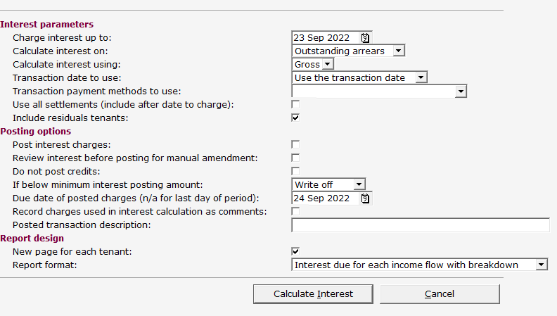

Complete fields but NOT the Post Interest Charges – this will provide a view option to check.
Provide description to show on transactions
Once happy, repeat but tick the box for Post Interest Charges.
Interest appears in the Transactions and can be invoiced, if required.
Note: This will calculate the total interest. You may need to adjust if some interest has already been charged manually.
Also, If error message received – check the headings at Property level have been completed – will need to email Nikola Bell if needs updating
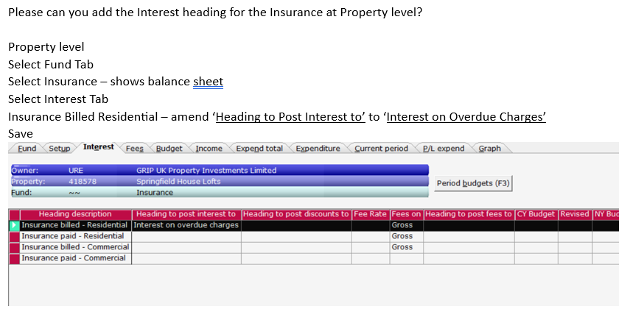

Interest on Rent review – below base rate
You may encounter a rent review where the interest on the backdated rent in the review is below the interest rate on the account, for example.
Lease Document

Rent review document
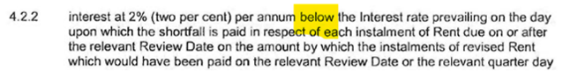
Interest, purely on the backdated rent from the review, will therefore be charged at (4%, less 2%),
so net 2% above base rate.

Reprinting Aldershot invoices for VAT
From Main Menu in Qube/ Reports
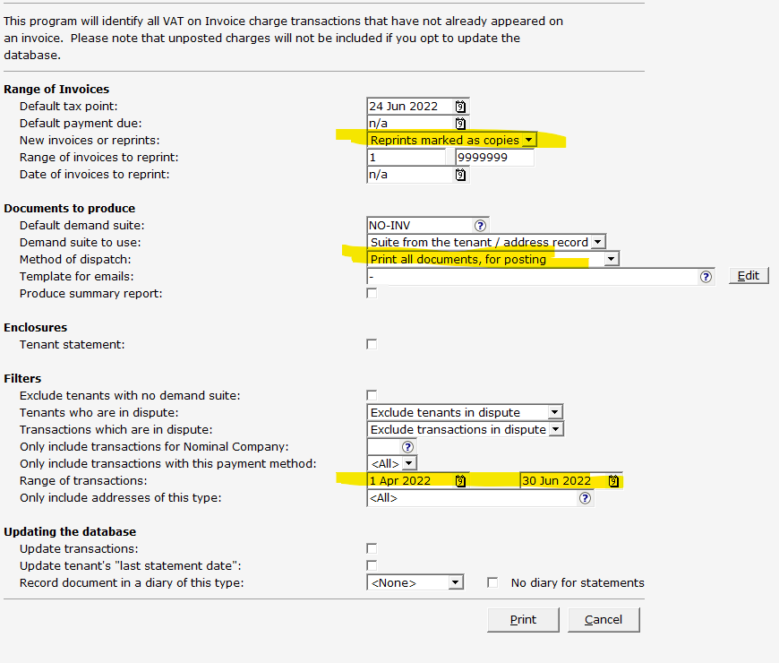
Select range of properties
Demand Suite will be MOD2

Enter transaction range according to quarter required

General Ledger – Report of Commercial Deposit Accounts
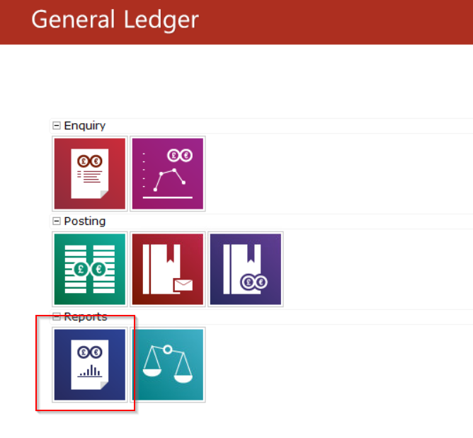

Select Reports option from main menu

Les - Need to complete this section

Payment through Salesforce

For Commercial Units, all payments are collected at the Contact level, rather than the Account level.

Direct debit authorisations are also set up at Contact rather than Account, as per the example below:

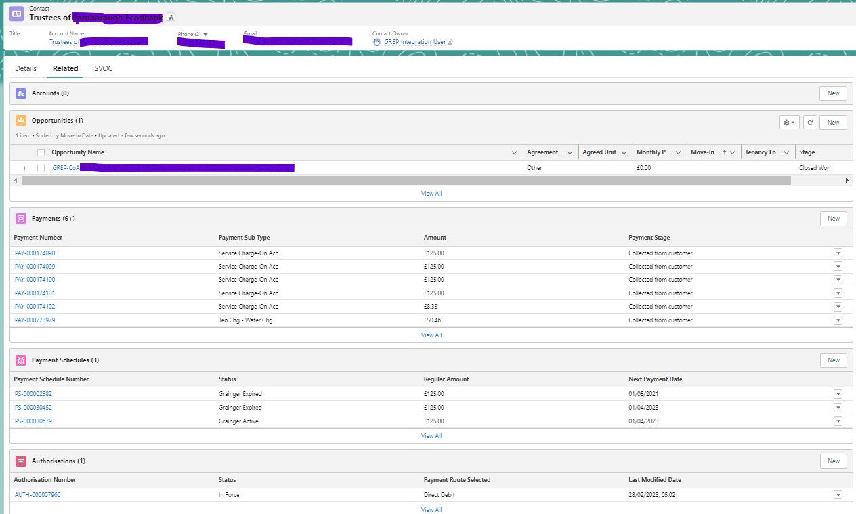

Anglo – Quarterly turnover reports – Additional Charges
Tenant ref - 418572004001
If 55% of revenue collected is higher amount than the quarterly rent charged, an additional charge needs to be raised.
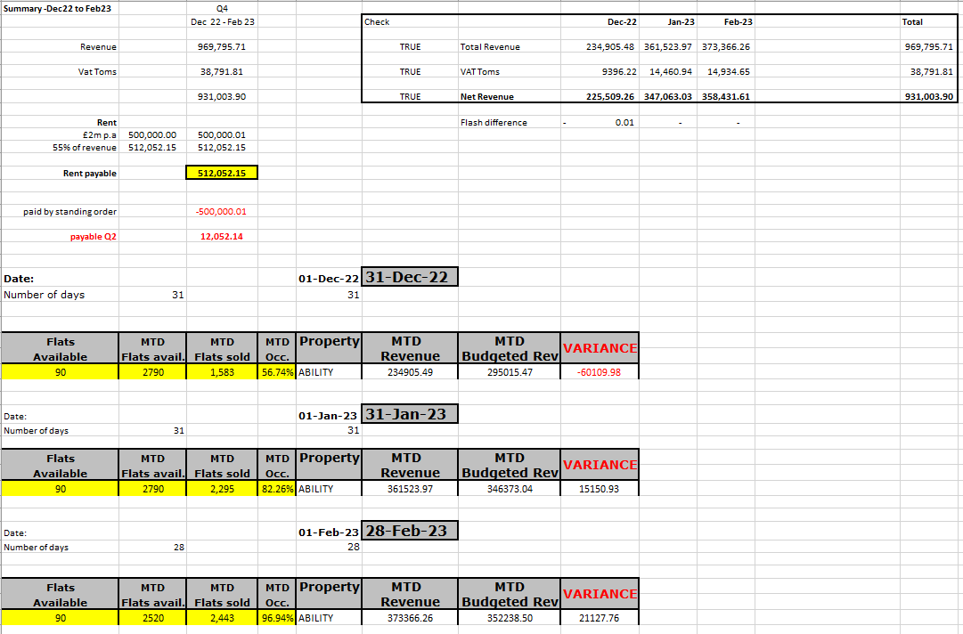
Quarterly “Flash Report” required with actual turnover values for the quarter.

Example of Quarterly “Flash Report” received with actual turnover values and figures

The ‘Payable’ amount in this example is £12,052.14 and a single charge needs to be raised for this .
This should be raised under ‘Commercial Rent: Non Vatable’ with a description of Single Charge for rent and the dates.
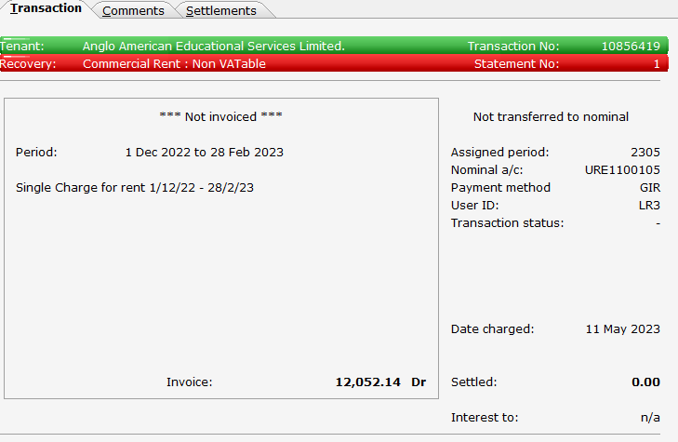

Example of Charge raised

This would then be invoiced as normal.

The Summary file name is “QUARTERLY FLASH REPORT SUMMARY - ABILITY REVENUE - ANGLO AMERICAN” and is held on the Accounts Drive at
M:\Accounting Resource\Accounting Resource\CREDIT CONTROL\Balance Reports

Appendixes

A Guide to the landlord and Tenant Act 1954
Link to Penningtons Manches Cooper website –
https://www.penningtonslaw.com/news-publications/archive-news/2012/a-guide-to-the-landlord-and-tenant-act-1954
A GUIDE TO THE LANDLORD AND TENANT ACT 1954
Posted: 27/07/2012

The Landlord and Tenant Act 1954 governs the rights and obligations of landlords and tenants of premises which are occupied for business purposes.
Here we outline the machinery for the working of the Act:
Summary
Security of tenure for the tenant
In broad scope, the tenant of premises from which a business is carried on has security of tenure when the agreed term of his lease comes to an end. This means that, even though the fixed term of the lease has ended, tenants of business premises have:
the right to remain in occupation at the end of the contractual term of a lease; and
the right to apply to court for the grant of a new lease.
Grounds for regaining possession
The landlord can only object to this and regain possession of the property on certain specified grounds, the most important of which are:
where the landlord requires the property back either for development purposes, or to occupy himself;
where the tenant has a history of non payment of rent, or not complying with the lease obligations;
where premises have been split up by subletting into a number of units and the whole premises would command a higher rent if let together under one lease.
In most cases lease renewals are conducted against the background of these statutory rights without any application to court being made and renewals are concluded by agreement between landlord and tenant, rather than by court proceedings.
Exclusion of security of tenure
The security of tenure conferred by the Act can be excluded by agreement. This is most usually done where:
the landlord intends to carry out a redevelopment;
the lease is for a very short term;
it is an underletting of a part of a larger holding.
Importance of professional advice
The Act sets out strict procedures which need to be followed, and makes provision for service of formal notices to exercise rights conferred by the Act. It is essential to take specialist advice (both legal and surveying) about the effect of any notice and what action should be taken to protect the position under the Act.
Terminating leases with security of tenure
Leases often have contractual rights for tenants to terminate a lease during its term (commonly referred to as break clauses). This note does not cover the manner in which these rights can be exercised. Specific advice is needed about these provisions which may require very strict compliance by the tenant of conditions in the break clause.
Under the Act a business tenancy which is protected will continue (even after the end of the stated term granted by the lease) until it is brought to an end in a number of different ways set out by the Act.
This concept is extremely important (from the point of view of both the landlord and the tenant) because it may be in the interest of either landlord or tenant to take action when the lease is nearing its expiry.
Some notices given in accordance with the Act must be in the form set out by the Act, but some need not be in any particular form. However legal advice should be obtained before serving any notice. Even small technical errors in the giving of a notice can render it invalid. The consequences of that can be very serious.
The most common notices bringing an existing, protected business tenancy to an end are the following:
Notice by the landlord under section 25 of the 1954 Act (section 25 notice)
This is a notice given by the landlord. It cannot be given before the last year of the term of the lease, nor can it be given after the tenant has served upon the landlord a request for a new tenancy under section 26 (see below). In effect it allows the landlord to start a procedure which will end, either in the tenant being granted a new lease, or in the tenant vacating.
A section 25 notice must specify the date on which the landlord proposes to bring the existing lease to an end.
The date of termination in the notice cannot be earlier than:
the end date of the lease; or
six months from the date of giving the notice
It cannot be later than 12 months after the date of that notice.
The notice must also:
state whether the landlord will oppose any application to court for a new lease, and, if so, on which of the grounds laid down by the Act;
outline terms on which the landlord is prepared to grant the renewal lease, the length of term proposed and the rent which the landlord is seeking.
Request by the tenant under section 26 of the 1954 Act (section 26 request).
This is a notice given by the tenant requesting a new tenancy upon termination of the old one. A section 26 request must specify a date on which the existing lease is to end.
It cannot be served before the last year of the agreed term of the lease, nor can it be served after the landlord has served a section 25 notice.
As in the case of the landlord's section 25 notice the date of termination cannot be earlier than six months after the date of the section 26 request nor more than 12 months after that date. A section 26 request cannot bring the existing lease to an end before its normal expiry date.
The section 26 request must also set out the tenant's outline proposals for the terms of the new lease, covering the same points as set out above for the section 25 notice.
Notice by tenant expiring on or after the lease expiry date under section 27 of the Act
The tenant alone has the right (under section 27 of the Act) to bring the tenancy to an end:
by giving notice at least three months before the date on which the tenancy would otherwise expire. Such a notice is recommended when the tenant does not wish to renew his lease and wishes to be sure that his lease is not continued automatically by the application of the 1954 Act;
if the term of the lease has expired but the tenancy is continuing under the 1954 Act, the tenant may bring that continuing tenancy to an end by giving not less than three months' notice in writing to the landlord.
It is important to note that if a notice is served under section 27 of the Act, the tenant no longer has any right to remain in occupation following the expiry of the notice, and loses the security of tenure protection conferred by the Act.
Consequences of service of notices under sections 25 and 26 of the Act
If a section 25 notice or section 26 request is served:
either party has the right conferred by the Act to apply to court for the grant of a new tenancy to the tenant, but must comply with the required timescales to preserve this right;
the landlord can oppose the tenant's application for a new lease, if he can satisfy one of the specific grounds of opposition mentioned above in the introductory summary (see 'Ground for regaining possession').
either party can also apply for an interim rent to be determined which is the rent payable for the period following the end of the existing lease until the date from which the new lease takes effect (or the date when the tenant brings the tenancy to an end);
the application to court must be made before the date of termination set out in the section 25 notice or section 26 request, although the parties can agree to extend this timescale, provided they do that before the date of termination. However if no application to court is made before the date of termination or any extended timescale agreed, the tenant loses the protection of the Act, and will have to vacate the property.
Opposition by the landlord to grant of new tenancy
This note does not attempt to deal with opposition by the landlord to the grant of a new tenancy in any further detail, because for the most part, landlords do not oppose the request for a new tenancy. Where they do, the specific facts of each case will merit special consideration.
However, it is important to note the following:
the landlord must say whether he opposes a new tenancy (and if so on which of the specified grounds) in any section 25 notice he gives;
if a tenant makes a section 26 request, and the landlord wants to oppose it, he must serve a notice on the tenant indicating this and stating on which grounds he opposes it within two months of the service of the section 26 request;
if a landlord does oppose the tenant's application for reasons other than the tenant's non-payment of rent or other non compliance with the lease, the tenant becomes entitled to compensation on leaving, based on the rateable value of the premises;
The new lease granted under the Act
A significant benefit to the tenant of the renewal arrangements set out in the Act is that the court can oversee, and if the parties cannot reach agreement, decide:
the terms of the new lease to be granted;
the length of the lease; and
the rent payable.
Lease terms
Landlord and tenant are free to agree anything they like. However, if they cannot agree, and the court is asked to settle the terms, the starting point is that the new lease will largely reflect the terms of the expiring (or expired) lease. Either party can propose changes if they can demonstrate that the changes are reasonable for a modern lease in comparison with the terms of the expiring lease (eg because it was granted a long time ago, or because there have been changes in the law which need to be reflected in the lease).
However, the courts are extremely unlikely to agree to the inclusion of terms against the will of one of the parties if these depart from the underlying commercial terms incorporated in the previous lease and change the balance of the commercial bargain between the parties.
Length of lease
The court is not able to order the grant of a lease for a term of more than 15 years, although this doesn't stop the parties agreeing a longer term if they choose. Generally speaking the courts will be more likely to agree to the length of term requested by the tenant than by the landlord.
So if a tenant wants a short lease, even if the old lease was for a much longer period, the landlord may not be able to insist on the tenant taking a longer lease. If the tenant wants a longer term than the landlord is prepared to agree to, and the landlord can show that he needs flexibility, perhaps because he has development plans, the court may order the inclusion of a break clause.
Rent
If the parties cannot agree the rent to be paid, the court also has power to decide this. This is to be a market rent, which is to ignore the fact that the tenant is in occupation, and any goodwill of the business carried on there, and is adjusted to ignore the effect of certain types of improvements carried out by the tenant at his expense.
Tenancies excluded from the Act
If the landlord and tenant have agreed that there should be no security of tenure conferred by the lease, formal steps need to be taken. Before the grant of the lease, or exchange of agreements for lease:
the landlord must serve a formal notice on the tenant in a prescribed form;
the tenant must respond by making a declaration, also in a prescribed form, that he understands the effect of the lease being excluded from the protection of the Act.
A lease which has been excluded from the protection of the Act will expire on the term expiry date stated in the lease (or earlier if any break right is exercised) and will not benefit from the continuation tenancy conferred by the Act. Accordingly:
the tenant will have no right to carry on his business from the premises or to remain there;
unlike a lease with security of tenure under the Act, the landlord has complete discretion whether he grants a new lease to the tenant and does not have to give any reason for refusing to grant a lease or explain why he wants the premises back;
if the landlord is willing to grant a new lease, there is no presumption that this will follow the terms of the previous lease.
If, against the wishes of the landlord, the tenant remains in occupation of the premises, then he would be a trespasser and would be liable to the landlord for damages. The landlord would also be entitled to obtain a court order requiring the tenant to vacate.
Another important effect of agreeing to exclude the security of tenure provisions of the Act is that the right of the tenant to compensation upon being compelled to vacate the premises is excluded.
The Landlord and Tenant Act 1954 is highly technical and this article should be treated as a guide only. It is a summary of the more important aspects of the Act and necessarily simplifies some of the Act's provisions. Legal advice should always be sought in connection with any specific matter.

Updating bank interest rates

Needs to be done by IT

In Tables Database you need to go to File > Bank Interest Rates. Select the right bank and Add a new interest amount and when to start it from.

URL: https://www.barclayscorporate.com/interest-rates/barclays-base-rates/

Sheengate Mansions Service Charges

This service charge is run by Sweetings, who will provide figures to calculate the service charges.
These are provided to Purchase Ledger, who should forward and provide actual values for Landlord Contributions
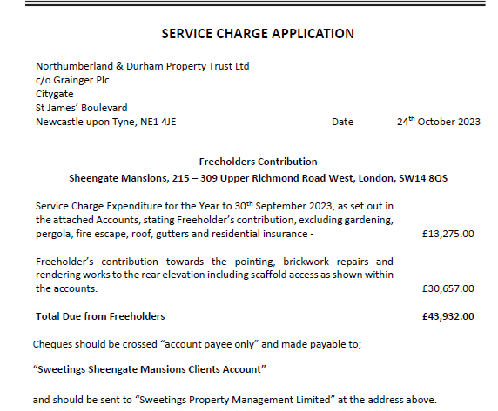

Example of Service Charge application – Purchase ledger to confirm this has been paid.

Breakdown between buildings and D&O values (D&O is separate policy – agreed with Pat, not required so just have one figure.)

Two Spreadsheets - with calculations for accounts and recharges can be found at:

M:\Accounting Resource\Accounting Resource\CREDIT CONTROL\Commercial process for ler\Service Charge unit expenses\Sheengate Service Charge Calculations

Password for protected worksheets (Acct’s & recharges) - sheengatesc

Spreadsheet for Accounts:
File Name: Sheengate Mansions - Accounts information – yearly

Create a new tab for each year and copy format from previous year to keep formulas - update the values.

Sweetings will supply the values, and these will need to be added into the new tab for each year using the percentages provided.

Spreadsheet for Recharges
File Name: Sheengate calculations for Recharges to accounts

Create a new tab for each year and copy format from previous year to keep formulas - update the values.

Check current tenant ref are correct and any roundings that may need to be adjusted.

Calculate the balances for each unit.

**** Once agreed protect the worksheet so cannot be altered and SAVE.******

Create a batch in Qube using the heading Sundry Rental Income and the description showing the unit number, eg
Service charge year End 30/09/21 S299
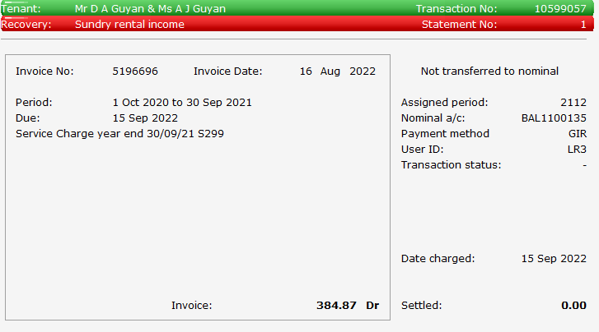
Produce invoices and issue with Sweetings breakdown

Example Commercial letters

GTCOMM1 – Gentle reminder – Outstanding entries shown
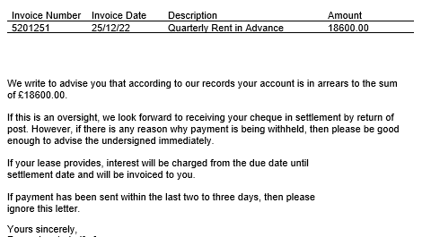

Gentle reminder with entries shown

GTCOMM2 – Gentle reminder – No Outstanding entries shown
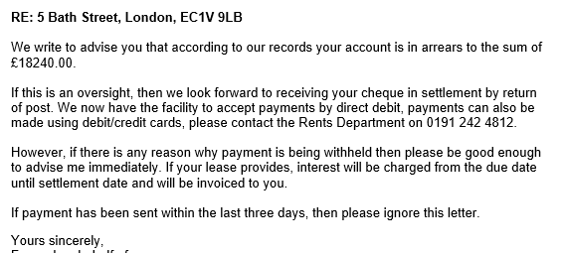

Gentle reminder without entries detail

GTCOMM3 – Reminder – Payment within 7 days
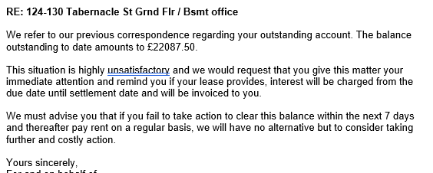

Stronger letter giving 7 days to pay – no entries detail

GTCOMM4 – Final Warning Letter



Final Warning letter – gives 48 hours for payment

GTCOMM8 – reminder for Non Rent/SC – e.g. Insurance
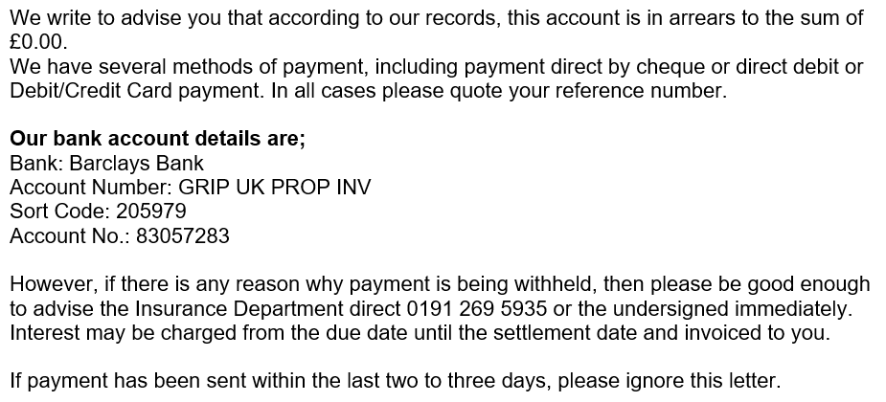

Reminder with pyt options

Usually used for Non-rent/SC or Insurance

NB: Having reference to cheques removed from letters – IT ticket 115379 – ler - 23/5/23

